Getting Started with PowerShell (PS) and Windows PowerShell Integrated Scripting Environment (ISE)

Nikola Petrovski 2018

27 MAY 2018

**1.0 Windows PowerShell**

The purpose of this lab is to get familiar with the following software products: Windows PowerShell and Windows PowerShell Integrated Scripting Environment (ISE). It provides step-by-step pictorial instructions for scripting in the command-line environment that is available in Windows Server 2012 R2 operating system.

Scripts represent simple and automated approaches for performing repetitive administrative functions. Windows PowerShell contains cmdlets that run in the command-line environment. A group of related cmdlets form a script. Modules are created for applications to manage all their service aspects for example print management and network adapter configurations. One of the existing Windows PowerShell features is tab-completion that alleviates typing long lines of text. Information about each Windows PowerShell cmdlet is accessible by typing a simple "Get-Help" cmdlet. Cmdlet is a simple Windows PowerShell script that performs a single function only.

Windows PowerShell cmdlets follow the verb-noun syntax. Every noun has a collection of verbs that is related to it. Commonly used verbs in cmdlets are:

* Get
* New
* Set
* Restart
* Resume
* Stop
* Suspend
* Clear
* Limit
* Remove
* Add
* Show
* Write

It is possible to display all the verbs related to a particular Windows PowerShell noun by typing: Get-Command-Noun. The presentation of all the nouns related to a particular Windows PowerShell verb is performed by typing: Get-Command-Verb. To display all parameters related to one cmdlet, type: Get-Help cmdlet. For trying if a certain cmdlet exists type: Get-Command cmdlet.

NOTE: All Windows PowerShell parameters are typed with "-" prefix. Each cmdlet can be related to a specific set of parameters.

This example represents a start of a background job (playing audio beeps):



To display the current week in the year :



Example of tab complete:

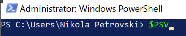 press tab

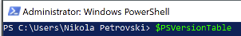 press enter



To display software version:



To confirm the software version number is “4.7” not “4.5”:



Using the Registry Editor is an alternate method for checking the software version :



This example displays all installed programs, their version, publisher and install date:



To export this list in a text file the path to the text file must be followed by “.” :



To compare two different lists file the previous example is used to create two separate files first and then PS allows pointing out the files differences by using (=>) or (<=):



In addition to Get-Command, the query can be narrowed by adding parameter(s) e.g., IP:



To query for specific module use:



To get help:



To get the properties and methods of objects:



To get a list of processes/objects that are running on the local/remote computer and their properties and methods: 

This example shows how to code a script that opens the Notepad, waits for user input and when the notepad window is closed by the user it opens the Calculator:

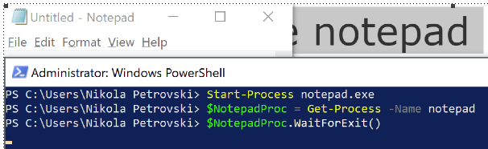

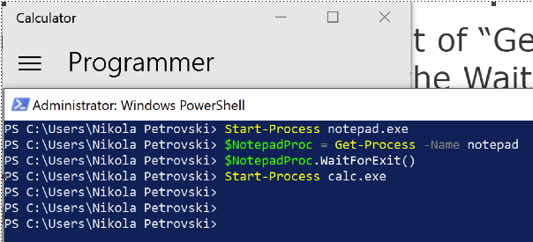

This example lists processes that match with Opera criteria:



This example is a notepad file saved in ps1 format that can run in the PS:



NOTE: PS execution policy settings may prevent a script from running. Setting it to RemoteSigned makes the script runnable.

Running a script that displays “format ps1”:



**2.0 Windows PowerShell Integrated Scripting Environment (ISE)**

Windows PowerShell IDE alleviates the use of Windows PowerShell. It has a built-in mechanism for typing autocomplete and can provide all the information about each cmdlet and its respective parameters. It can execute PowerShell commands and save scripts for later usage. It highlights the keywords and debugs scripts.

This screenshot shows the interface for displaying and running the scripts :

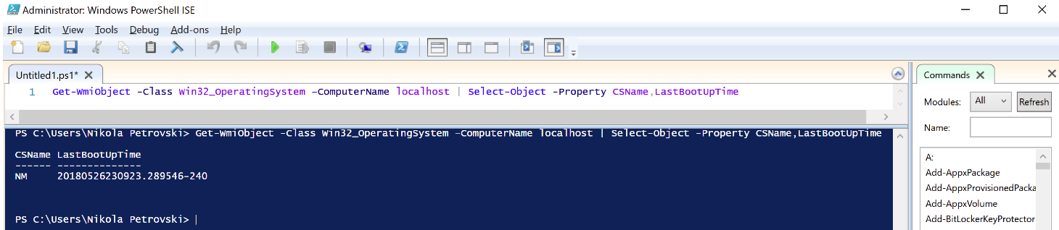

To make the Last Booted date more human readable modify the script to state:

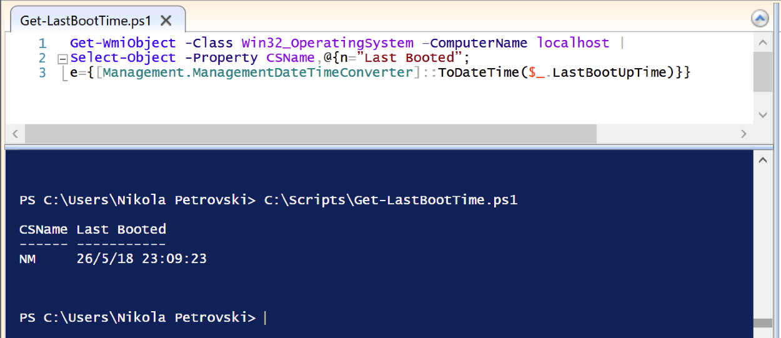

Revising the previous script to allow cross computers application of the script:

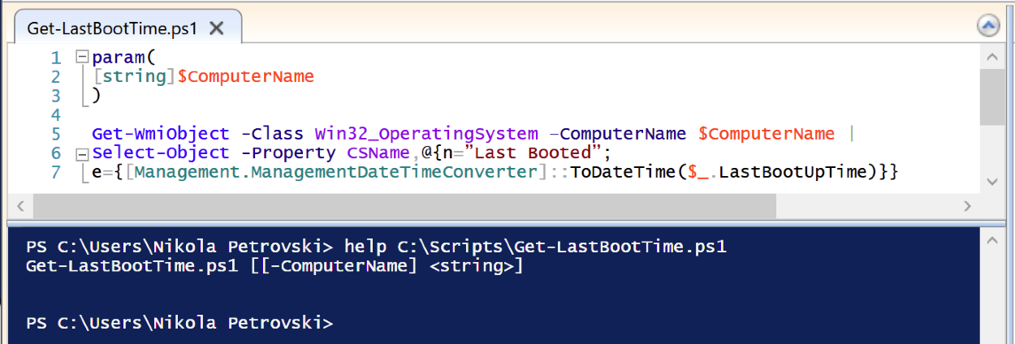

To specify the name of the computer and make this input mandatory:

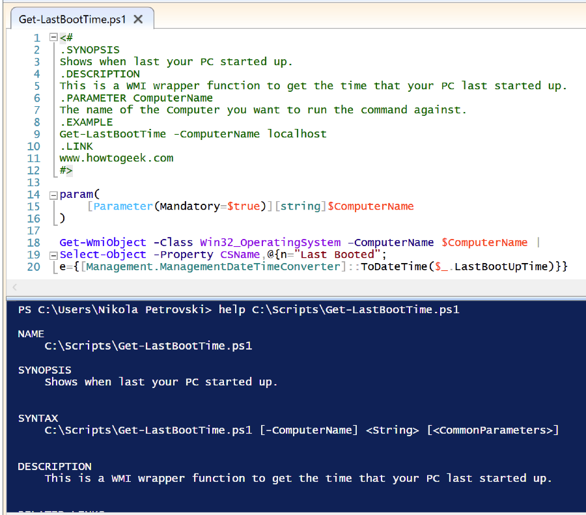

Complete script:

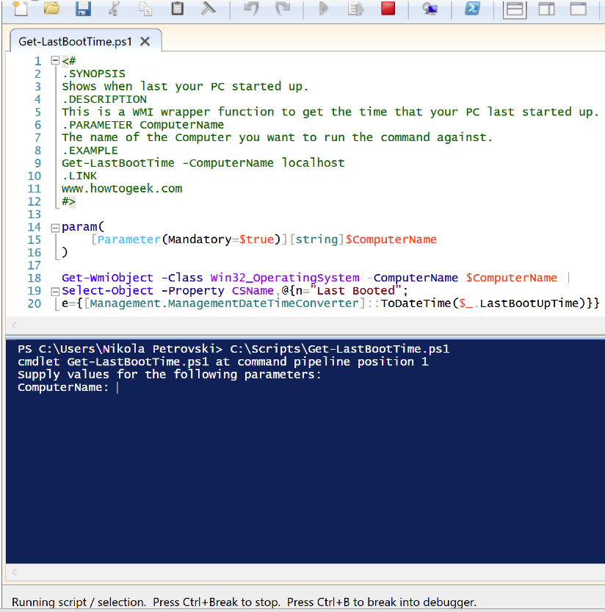

After input:

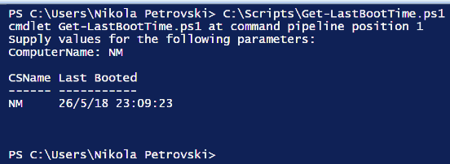

Variables, Inputs and Outputs are critical for any script. If a variable named “FirstName” is created by typing: $FirstName = “Bob” then it can be deleted as shown below:

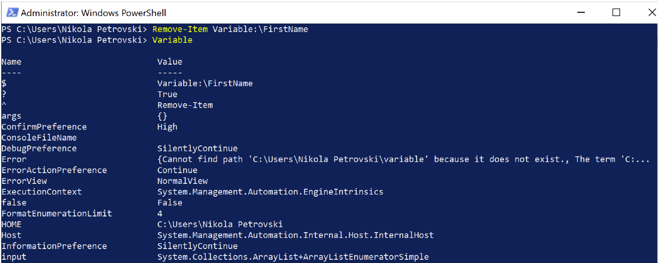

Variable can store more than one thing e.g., 3 processes objects :

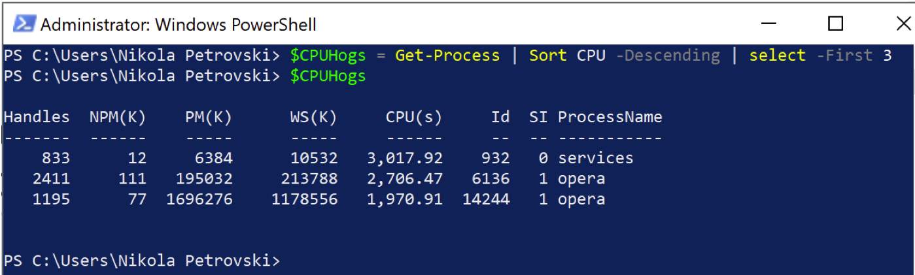

NOTE: In PS the variables that hold a collection of objects can be identified, specified and divided into single objects by using the array like syntax. To get the first object in the collection type: $CPUHogs[0]. Also, the order of operations determines if the result from “+” symbol will be addition or concatenation result. In PS casting is used to prevent any exceptions “[int]$Number = ‘5’. For example:

$2 = 10

$b = ‘20’

There are two combinations:

$a + $b = 30

$b + $a = 2010

Input/Output :

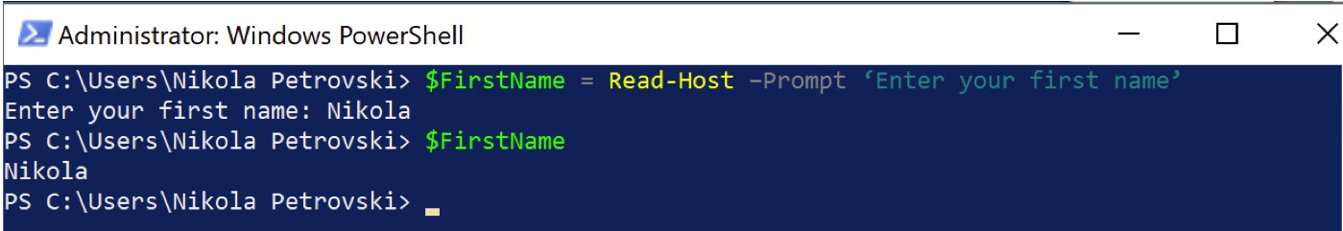

Write-Output:

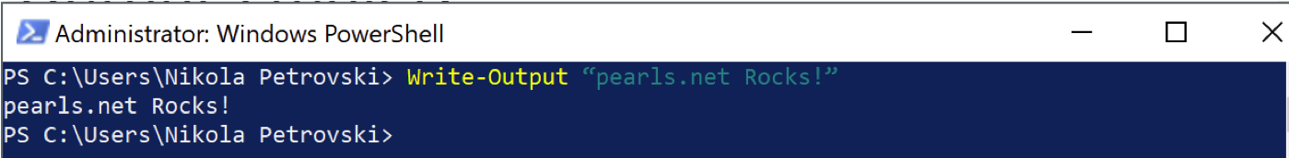

Using quotation marks and “NoNewLine” example:

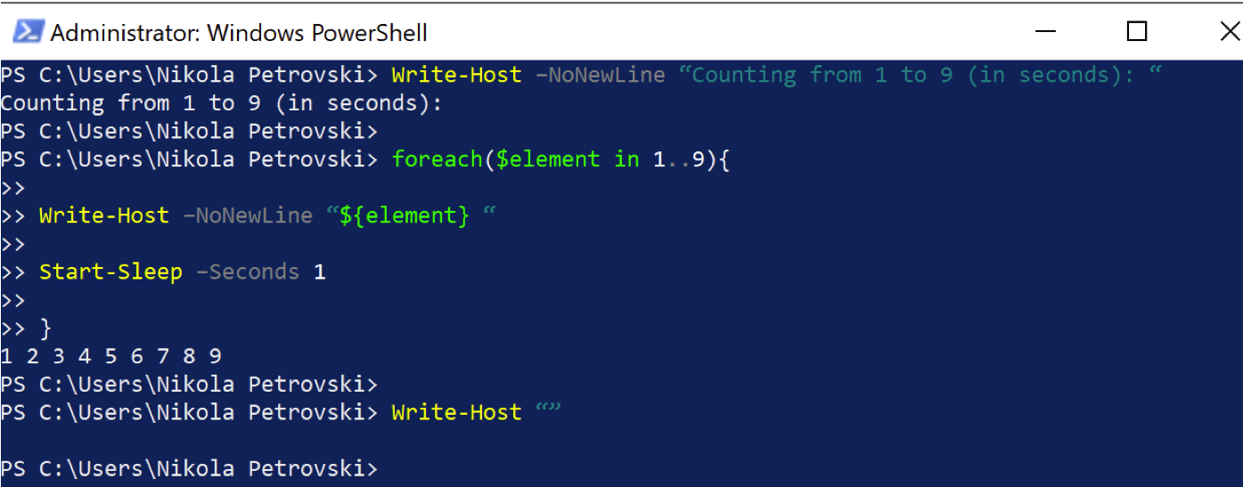

Using style and color for the output example:

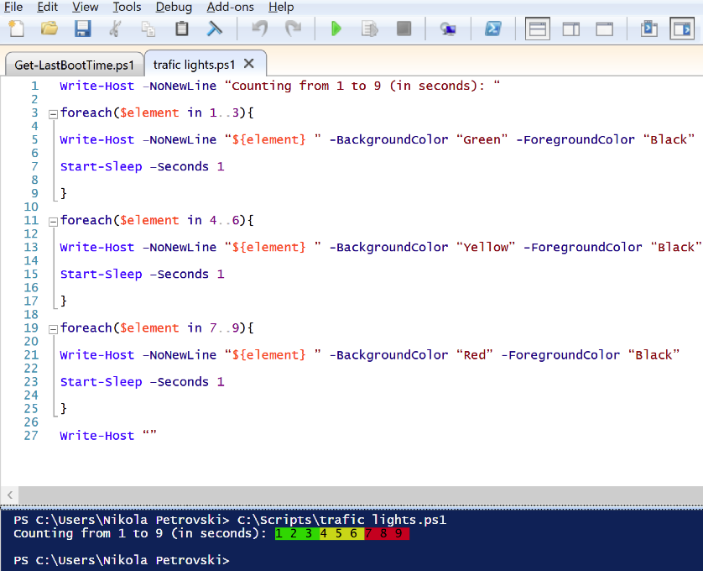

Example showing the contract between two cmdlets where redirection is used:

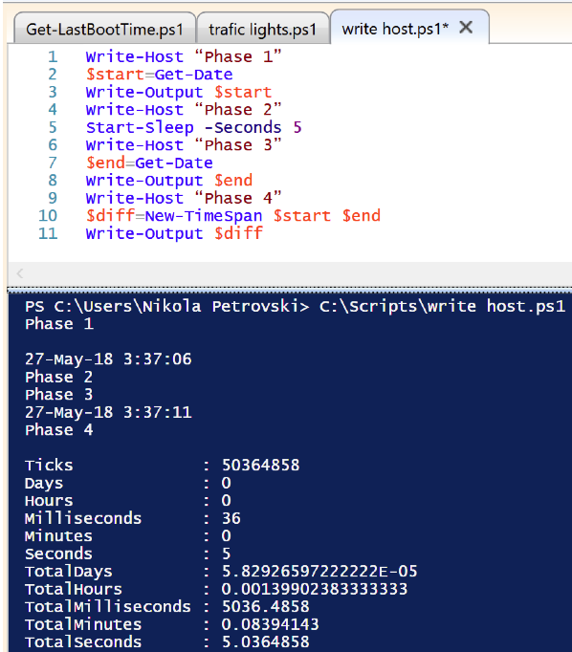

NOTE: Write-Host output is temporary. It is not captured on the screen but obsolete by the next output.

1. **Summary**

There are various scripts for folder permissions or NTFS permissions (PowerShell), for exporting Active Directory users to CSV as well as setting date formats.

Examples:

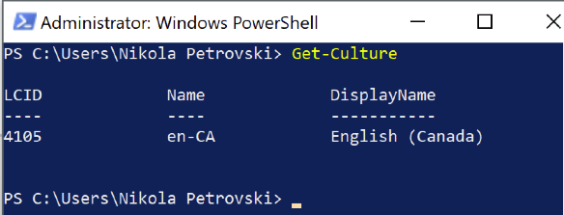

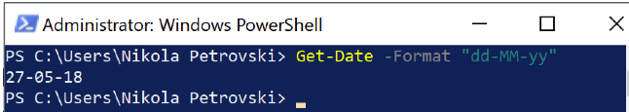

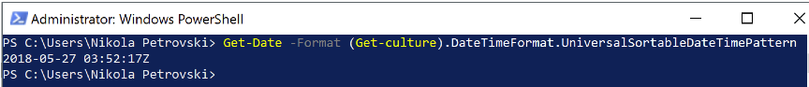

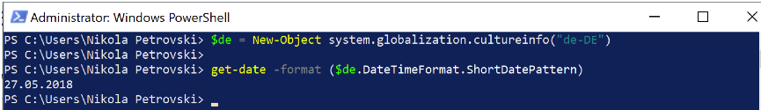

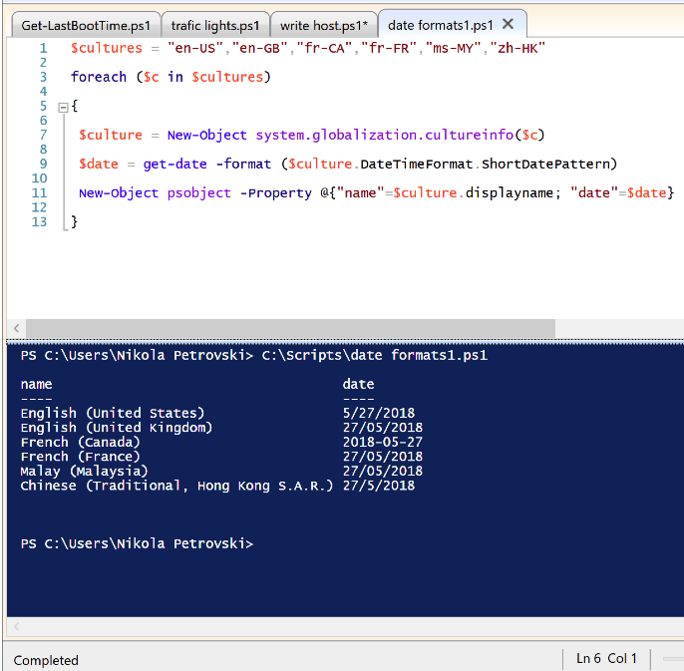

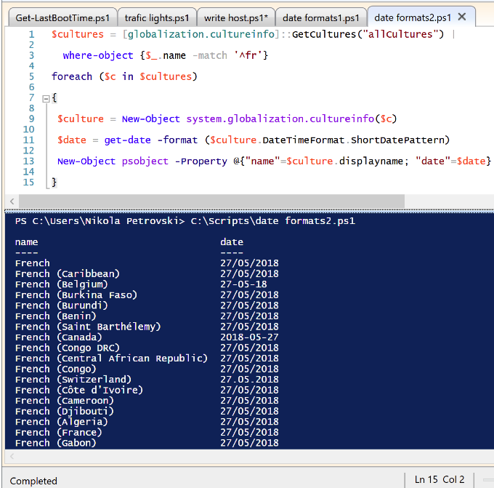

**4.0 References**

<https://docs.microsoft.com/en-us/powershell/>

<https://docs.microsoft.com/en-us/powershell/scripting/core-powershell/ise/introducing-the-windows-powershell-ise?view=powershell-6>